Activate Voice on Active Broadband Over Cable Service

Version Control:

Use Case Name: |  | Activate Voice on Active Broadband Over Cable Service
Use Case Owner: |  | Sumit Borade
Current Version |  | 0.4
Use Case Version History
Modified Date | Version |  | Modified By | Change Description
June 28, 2009 | 0.1 |  | Tom Schnarr | Initial Version
July 8, 2009 | 0,2 |  | Tom Schnarr | Defined future date support handled by Triple
August 26,2009 | 0.3 |  | Sumit Borade | Removed steps not relevant to SMP
Oct 31,2009 | 0.4 |  | Sumit Borade | Reboot step before Voice Services provisioned on CISCO BTS

Brief Description:
This use case describes the process by which a YouSee subscriber orders voice service over cable to be deployed on their broadband voice service.

Related Documents
- YouSee SMP SOW2Architecture Requirements Document
- YouSee SMP SOW2 Business Requirements Document
- Activate Broadband Cable
- Cisco BACC TC Specification
- Cisco BTS TC Specification

Related Use Cases

Pre-Conditions
- Subscriber resides in a residence served by YouSee cable footprint
- Subscriber is an acceptable credit risk.
- Subscriber is currently a broadband subscriber with an eMTA device

Post-Conditions
- Subscriber is free to use Voice over Cable service.

Use Case

Primary Flow Diagram
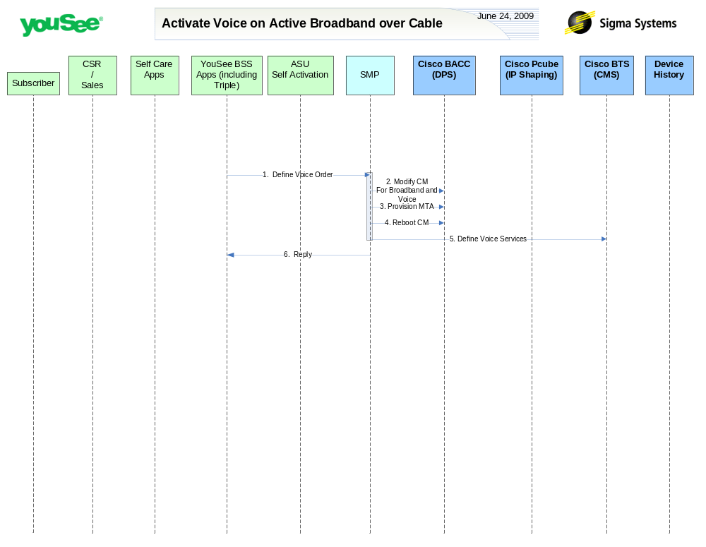

Primary Flow Detail
# | Actor: Key Action | Description | Alternate Flows/Details
 | YouSee BSS: Order is communicated to SMP to add Voice Services | Activate Voice order is communicated from Triple to SMP. Existing Broadband subscriber orders additional service.
 | SMP: modifies CM in BACC | SMP updates the configuration of the CM in BACC to include the voice and broadband service
 | SMP: defines MTA in BACC | The MTA is provisioned in BACC with the appropriate services
 | SMP: requests BACC to reboot the CM Device | <As in Activate Broadband Service Use Case>
 | SMP: provisions voice service in BTS | Sigma defines the voice service in the BTS including defining  - Gateway (mta)  - Subscriber/voice line  - Associating subscriber to gateway  - Setting the entities to an activate status  Assigning call features
 | SMP: Replies back to ASU the status of Activation | SMP will reply to ASU the status of Provisioning Order to ASU. | If Provisioning fails then SMP will put the Failed task in Manual Queue.

